Week 1
Introduction to AI, GAI and GAI-powered applications

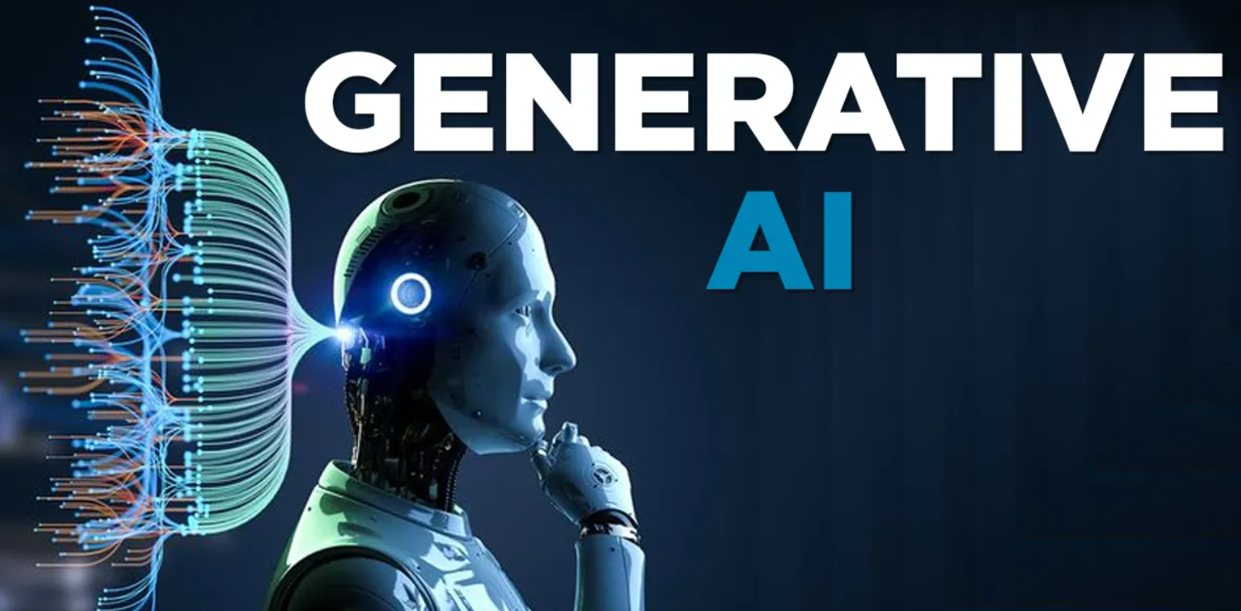
Learning Outcomes:

By the end of this session, students should:
- Have a basic understanding of Artificial Intelligence (AI), Machine Learning (ML) and Generative AI (GAI)
- Be able to form effective teamworking strategies
- Understand ICT Task Sheet
- Recognise how the “What? So What? Now What?” model serves as the structuring tool for this assignment.
- Have practiced English pronunciation – final consonant sounds
Task 1: Lead-in
Real or AI Quiz: Can You Tell the Difference? (H5P)
Each set contains one real image and one that was generated by AI. Select the real image.
Category | A | B
Poisonous Frogs | 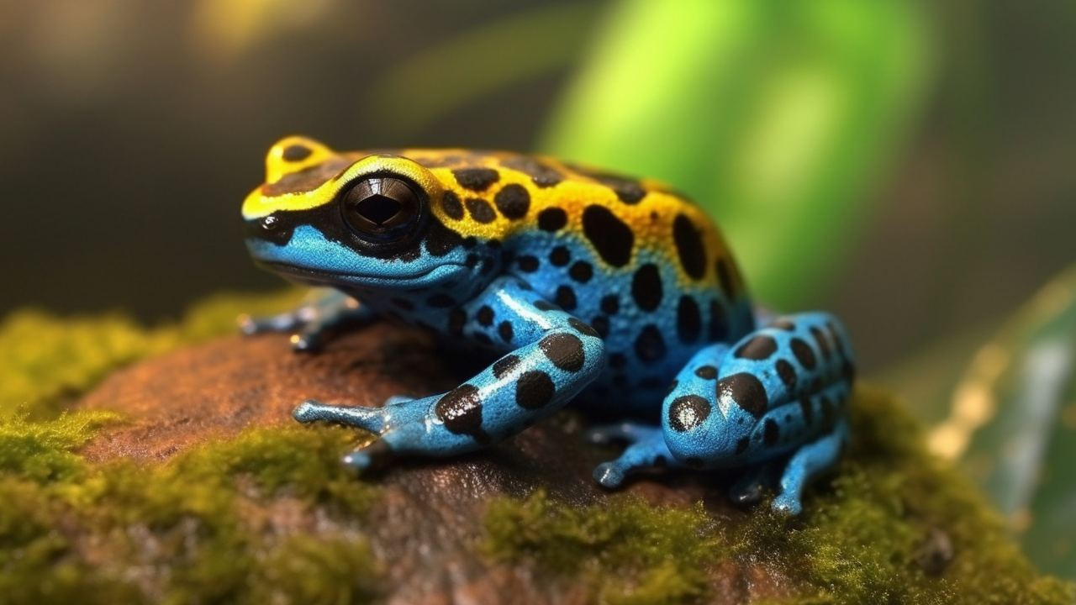 | 
The Titanic |  | 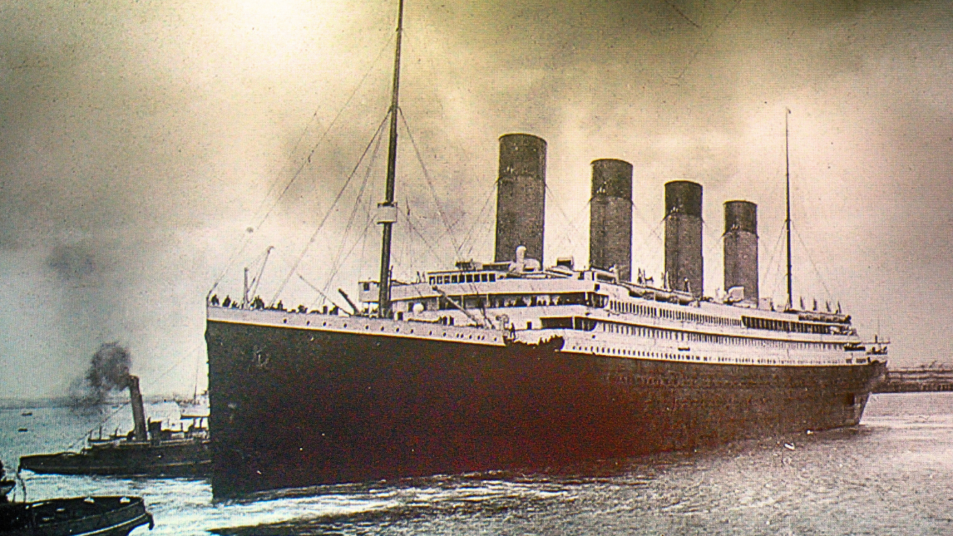
Mount Fuji |  | 
Shuttle Launch |  | 
Aurora Borealis (The Northern Lights) |  | 
Ancient Egyptian Papyrus | 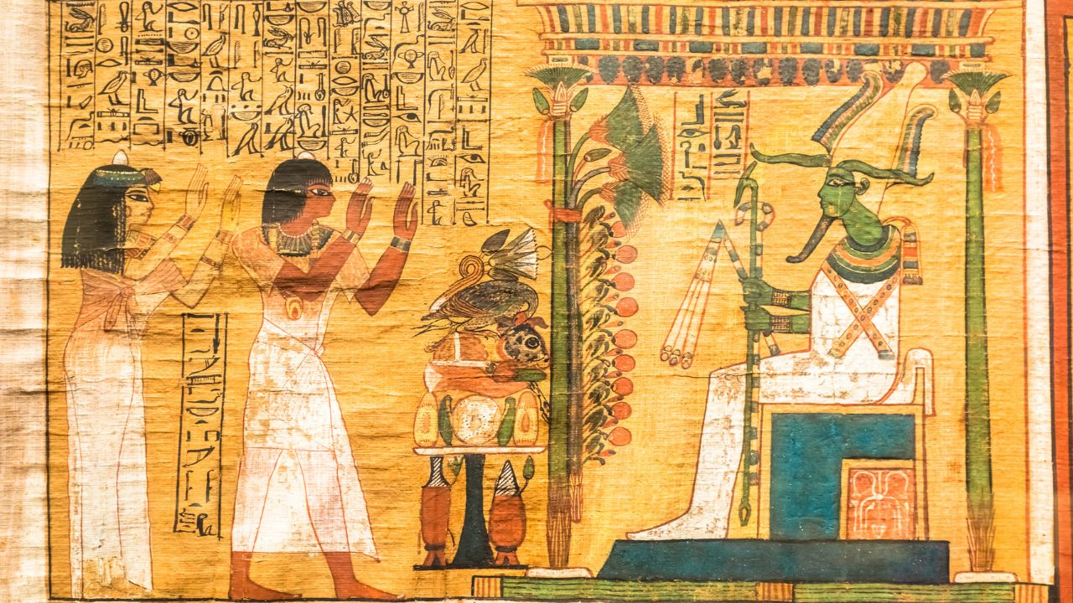 | 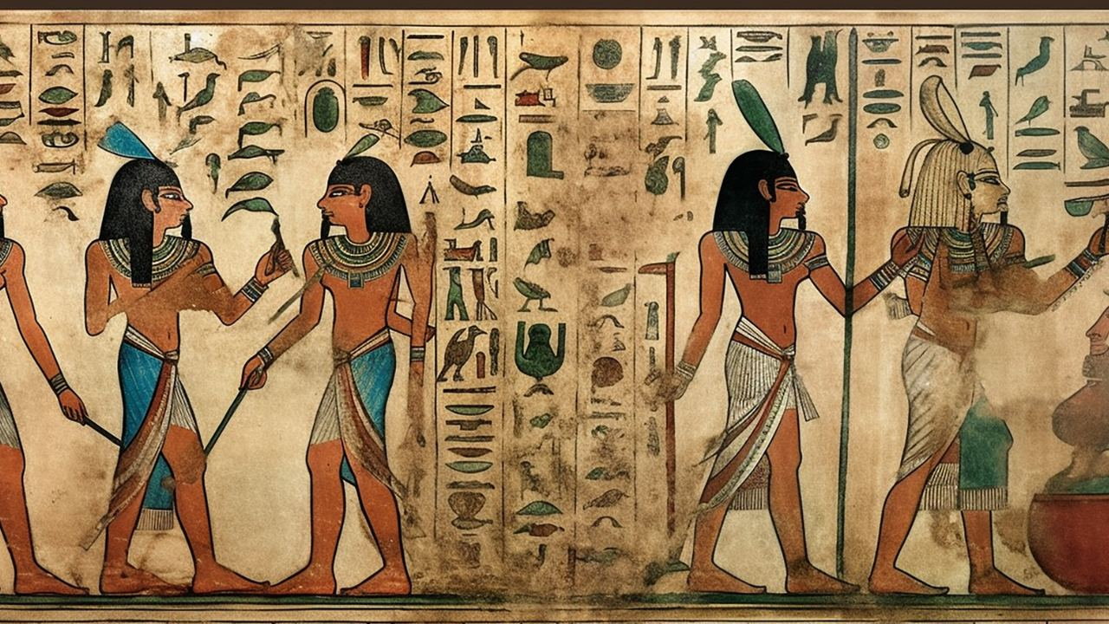


Task 2: Group Formation and Vocabulary-Building ⭐ Key Task
2A. Getting to Know Your Teammates (see group list on LMO)
a. Introduce yourselves to each other (exchange names).
b. Each member gives a one-minute introduction – tell the group about your interests, hobbies, hometown, major, and anything else you'd like to share.
c. Discuss your vision of teamwork: What does effective teamwork mean to you? How can your group work together to achieve 1+1>2?
2B. Group reading and match the terms with their definitions (handout)
Terms | Definitions
1. Artificial Intelligence (AI) | a) A computing system inspired by the human brain, made up of interconnected nodes (neurons) that process information and learn patterns from data.
2. Machine Learning (ML) | b) A class of AI models designed to generate new content based on existing data.
3. Generative AI | c) Models that are trained to classify or label existing data rather than generate new data.
4. Reinforcement Learning | d) The language that humans use for everyday communication, as opposed to formal languages used in programming.
5. Deep Learning (DL) | e) A technique used in generative AI where users provide natural language instructions to guide the output generation.
6. Discriminative Models | f) An advanced subset of ML using artificial neural networks to analyse complex patterns in large datasets.
7. Prompting | g) A type of learning where an agent makes decisions based on feedback from interactions with an environment, aiming to maximize rewards.
8. Natural Language | h) A subset of AI focused on developing algorithms that enable computers to learn from and make predictions based on data.
9. Neural Network | i) The simulation of human intelligence processes by machines, particularly computer systems

2C. Use the terms above to fill in the blanks in the chart below. You may use your previous knowledge and discuss with your partners.

____________________________
e.g., expert systems

B. _______________________
e.g., support vector machines

D. ____________________
e.g., large language models

C. ______________________
e.g., neural networks

Task 3: Group Reflection ⭐ Key Task
Discuss these questions with your teammates and share your reflections:
- What is one thing you learned from Task 2?
- How did your team work together? What went well?
- If you had to complete another group task in a future tutorial, what would you do differently?
Task 4: ICT Task Sheet Introduction ⭐ Key Task

Please open the ICT task sheet on LMO and get ready to answer questions on Kahoot.

Task 5: The ‘What? - So What? - Now What?’ Model ⭐ Key Task
Task 5a: In your groups discuss the following questions.

- What do you understand by the term ‘reflective writing’?

- Have you ever done any reflective writing before? How did it go? What did you do well and what did you do badly?

The ‘What? - So What? - Now What?’ Model.

When reflecting on a project, one of the simplest frameworks you can use is a set of three questions.
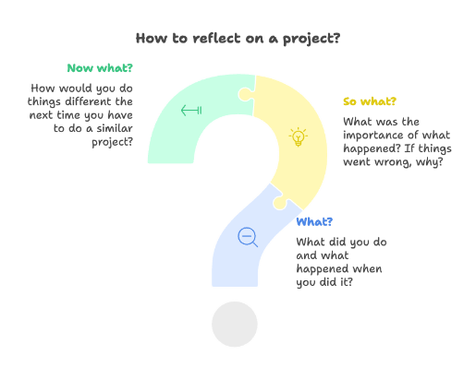
What? – What did you do and what happened when you did it?
So what? – What was the importance of what happened? If things went wrong, why?
Now what? – How would you do things different the next time you have to do a similar project?

Task 5b – Reading

Below are three sections of a model report of the reflective report you will be asked to write in week 9. It is divided into ‘what?’, ‘So what?’ and ‘Now what?’ sections. We will look at each one separately.

What?

Read the text below and answer the questions.

(Paragraph 1) During Practical Task 3 of our AI app design project, my responsibility was to evaluate and recommend a suitable AI platform for our mental health chatbot aimed at university students. The task took place over a two-hour lab session, during which I conducted a comparative review of GPT-4, Google Dialogflow, and IBM Watson, based on four criteria: natural language capabilities, ease of integration, ethical considerations, and data privacy features.
(Paragraph 2) I created a comparison table and presented initial findings to my team. We discussed the pros and cons of each platform. While GPT-4 offered the most advanced language generation, we were concerned about the lack of transparent control over outputs. Dialogflow offered a more structured, rule-based design that seemed safer for sensitive conversations. Ultimately, we decided to recommend Dialogflow as the foundation for our chatbot’s interaction model.

- What is the purpose of paragraph 1?
- What is the purpose of paragraph 2?
- Does the writer mention anything which went wrong?
- Does the writer mention how they felt about their project or task?

So What?
Read the text below and answer the questions.

(Paragraph 3) This task made me aware of how important early-stage platform selection is in shaping both functionality and ethical boundaries. Initially, I assumed the most advanced AI (GPT-4) would be the best choice, but our discussion revealed that in contexts like mental health, predictability and safety may matter more than generative power.
(Paragraph 4) I also learned that platform features can constrain or support ethical decision-making. For example, Dialogflow allows developers to define fallback responses and clearly direct users to human support when needed. This helped us conceptualise a safer user journey, reinforcing the need to consider not only what a platform can do, but what it should be allowed to do in context.
(Paragraph 5) This was the first time I applied ethical design principles—like user safety and transparency—to a technical decision. The task helped bridge theory and practice in a very concrete way, even without writing any code.
- What is the purpose of paragraph 3?
- What is the purpose of paragraph 4?
- What is the purpose of paragraph 5?
Now What?
Read the text below and answer the questions.

(Paragraph 6) In future projects, I’ll approach platform selection more critically, thinking not only about performance but also about user needs and ethical implications. I plan to improve my ability to assess third-party tools more efficiently and develop a checklist that includes both technical and social criteria.
(Paragraph 7) Next time, I would also push for quick user validation—perhaps a short feedback session with peers—to check whether our assumptions about safety and clarity align with how potential users feel.
(Paragraph 8) This short but focused task showed me how even one design decision can shape an entire app's direction. It made me more aware of the broader responsibilities involved in AI system design.
- What is the purpose of paragraph 6?
- What is the purpose of paragraph 7?
- What is the purpose of paragraph 8?

Task 5c – Wrapping-Up
Now look again at the whole report and answer the following questions.
- Did the student make any major mistakes during the project?
- Did the group have any major arguments during the project?
- Does the writer express any strong emotions they felt during the project?
Task 6: Pronunciation Practice - Final Consonant Sounds (optional)
Final consonants are consonant sounds that occur at the end of words.
Common final consonant sounds include:
Sound | Example Word | IPA |  | Sound | Example Word | IPA
/s/ | diagnosis | /daɪəɡˈnoʊsəs/ |  | /b/ | cub | /kʌb/
/n/ | Amazon | /æməzən/ |  | /f/ | leaf | /liːf/
/t/ | output | /aʊtpʊt/ |  | /v/ | generative | /dʒenərətɪv/
/r/ | barrier | /bæriər/ |  | /z/ | maximize | /mæksɪmaɪz/
/l/ | model | /mɒdl/ |  | /θ/ | bath | /bæθ/
/d/ | discord | /dɪskɔːd/ |  | /ʃ/ | fish | /fɪʃ/
/m/ | mechanism | /mɛkənɪzm/ |  | /dʒ/ | judge | /dʒʌdʒ/
/p/ | cup | /kʌp/ |  | /tʃ/ | match | /mætʃ/
/k/ | agentic | /ā-jen'tik/ |  | /ŋ/ | sing | /sɪŋ/

Practice:
- You would receive a card.
- Student A says one word per pair randomly.
- Student B circles 🟢 the word they hear on a worksheet.
- Discuss: "Was the ending clear? What helped you tell them apart?"
- Swap roles.

